Log in and run these commands to find your info 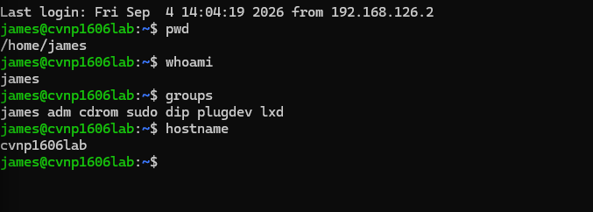
Made the directory and executable 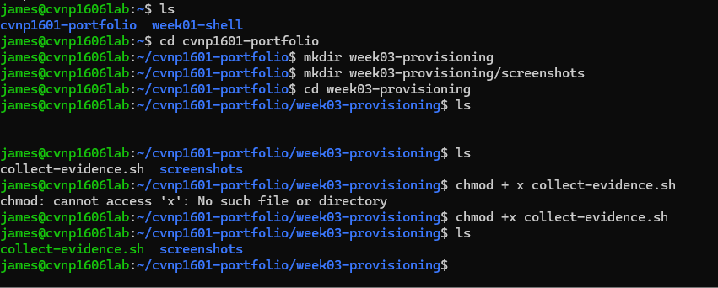
Got my password hash made and shown the devuser account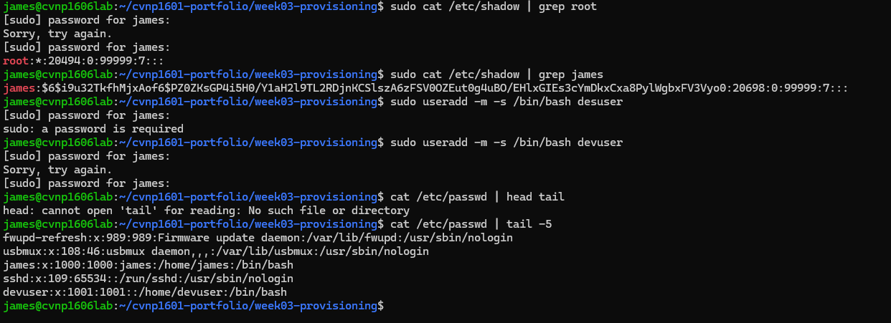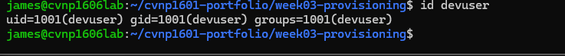
Added devuser to developers group 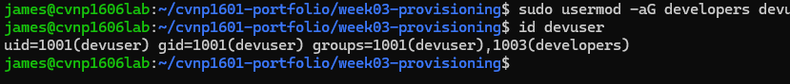added sudo rule 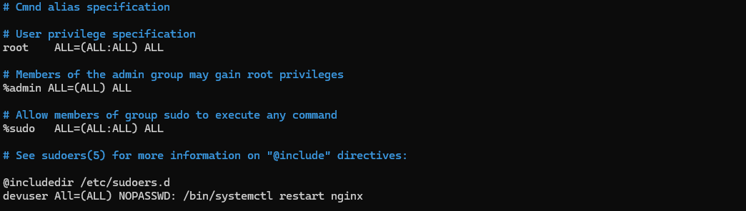
Proof of change had to go back and make ALL case sensitive in ALL=(ALL)
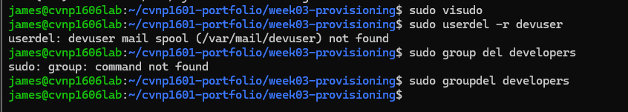
Clean up

